UML System Design

1 Use Case Diagram
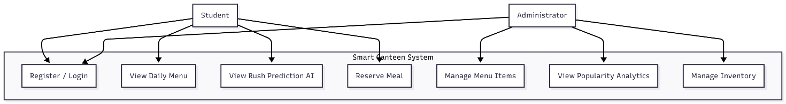

2 Sequence Diagram (Core Flow: Meal Reservation)
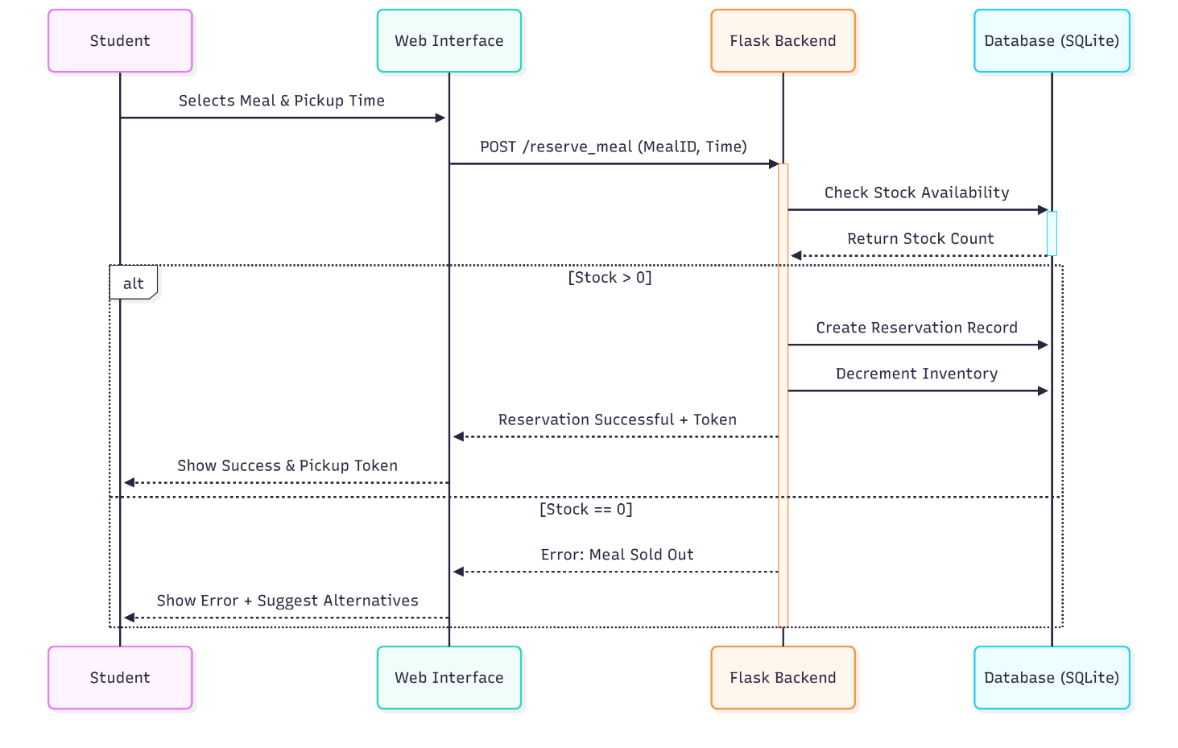

3 Activity Diagram (End-to-End Workflow)
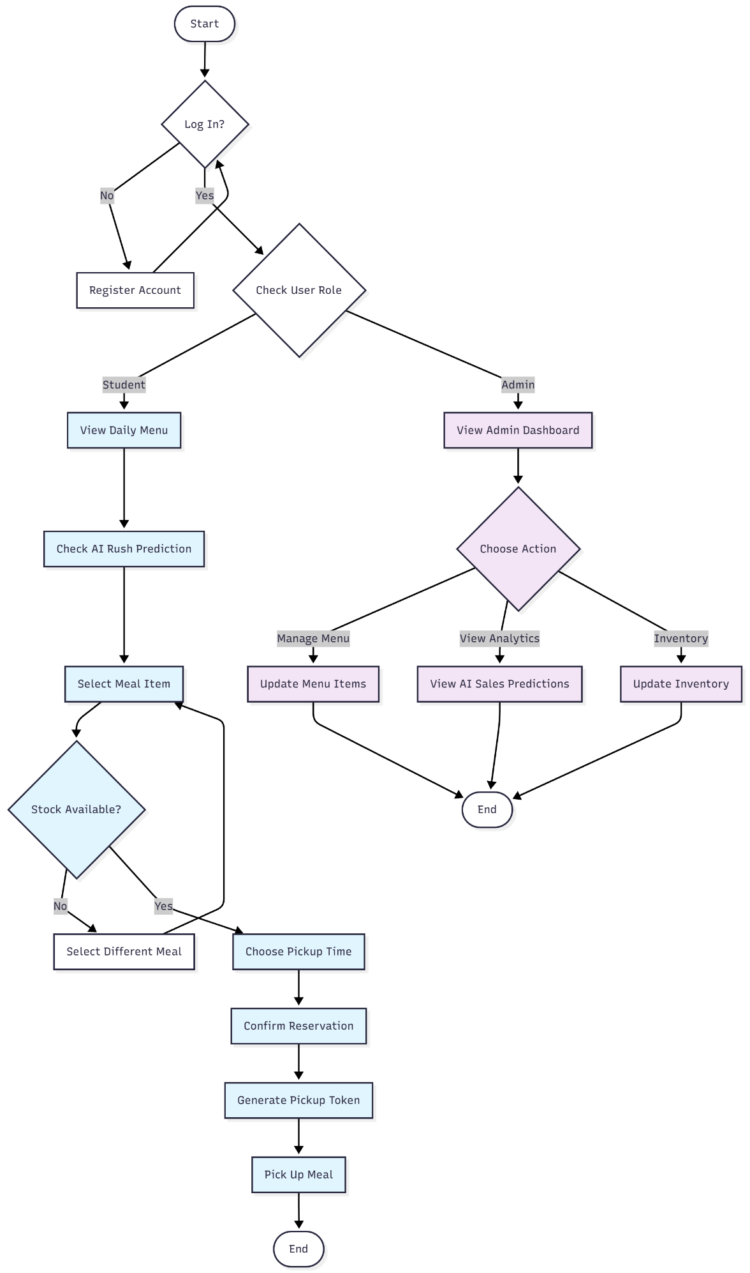
4 Class Diagram (System Architecture)
